### **Introduction (The Company)**

Syniad Software Ltd **A** **Hypothetical Company** that was started ten years ago by four friends. They still own most of it and are part of the Board of Directors. Syniad makes custom software for clients who want high-quality solutions. The company is based in London, with extra offices in Manchester and Delft, Netherlands.

### **Operations Director**

The Operations Director makes sure the company runs smoothly and makes money. They ensure that all employees stay productive and focused on their tasks. They also check if the company has enough materials, tools, or people to complete projects successfully.

### **Technical Director**

The Technical Director makes sure everything the company makes is good quality. They also work on new ideas and improvements. Plus, they help with staff training and presentations to show others what the company does.

The **Operations Director** focuses on efficient company functioning and resource management, while the **Technical Director** emphasizes quality control, innovation, and technical improvements.

### **Centralization vs Decentralization**

At Syniad Software Ltd, centralization means decisions and responsibilities are managed within specific groups, with managers guiding employees’ careers. This helps maintain control, consistency, and focus within teams.

On the other hand, decentralization happens when employees work across different groups for projects, allowing faster decision-making and more flexibility. However, it can make employees feel less connected to their original teams.

The company needs to balance both:

* Centralization keeps structure and clarity
* Decentralization encourages collaboration and innovation across teams.

**Management of Staff**

When Syniad had fewer than 50 staff members, it was easier for directors to know everyone well. Staff were loyal, often working extra hours and maintaining high standards. As the company grew, it became harder for directors to keep those close connections, leading to less loyalty among new employees.

As the company got bigger, it faced challenges in managing staff effectively. The directors tried to keep everyone informed and supported, but newer employees felt less connected than the older ones. This change caused a drop in loyalty to the company.

Every six months, the company checks employee performance and pays attention to their achievements. However, they struggle to maintain good management as employees move between different projects, affecting team identity and skills.

### **Producing the Budget**

At Syniad, the budget is divided between two main groups:

1. **Technical Staff** – These employees work directly on projects that earn money for the company. They need funds for tools, software, and other resources to complete their tasks.
2. **Non-Technical Staff** – These employees provide support, such as administration, HR, and marketing. They need funds to manage operations and assist the technical teams.

By allocating the right amount of money to each group, Syniad ensures both technical and non-technical staff can work effectively.

### **Monitoring Financial Performance**

To monitor financial performance, Syniad tracks its **monthly income and expenses**. This helps the company see if they are making or losing money.

Since managing finances can be complicated, they use a **system to track the costs and income for each project**. This way, they can figure out which projects are doing well and which ones need improvements.

Syniad uses two key reports to track sales:

1. **Confirmed Sales Report** – This shows the money coming in from signed contracts. It helps the company know what income to expect.
2. **Sales Prospects Report** – This tracks potential future sales. It gives an idea of new business opportunities that might turn into confirmed deals

### **Long-Term Planning**

Syniad’s long-term planning is about setting goals and figuring out how to solve problems that stop progress. They are thinking about expanding and hiring local sales and management staff. However, the company needs to fix issues like its image and financial problems.

### **Conclusion**

Even though Syniad has some challenges, it is a successful and well-run company. However, it might need to think about becoming a multinational company to keep growing. The directors will need to learn new skills to manage this change effectively.

Lecture 10

**HRM Issues**

Human Resource Management (HRM) helps a company run smoothly by handling important tasks like hiring the right people, training them, managing pay and benefits, and solving problems. HRM also ensures the workplace follows laws, especially those that protect workers' rights and prevent discrimination. It works to keep employees motivated, safe, and treated fairly, while making sure the company follows legal rules and regulations.These include:

1. **Hiring, selecting, and promoting staff** – Making sure these processes follow anti-discrimination laws.
2. **Training and developing staff** – Helping employees learn new skills and grow.
3. **Setting up and checking pay policies** – A **remuneration policy** is how employees are paid, including salaries, bonuses, benefits, and rewards.The **remuneration policy** includes things like salaries, bonuses, benefits (like health insurance), and rewards to motivate and keep employees happy.
4. **Employee performance reviews** – Setting up and monitoring how workers are evaluated.
5. **Handling dismissals and redundancies** – Managing when employees leave, either due to job cuts or other reasons.
6. **Employment contracts** – Dealing with agreements about job roles, responsibilities, and rights.
7. **Planning for staff needs** – Making sure the company has the right number of workers with the right skills.
8. **Handling employee complaints** – HRM takes care of problems when employees have issues or worries. They have a process to listen to these complaints and work to find fair solutions, helping to keep the workplace positive.
9. **Following new employment laws** – Keeping up with changes in worker rights and advising management on how to follow these laws.
10. **Health and safety** – Making sure the workplace is safe for everyone.
11. **Running consultative committees** – Setting up meetings between staff and management to talk about important issues.

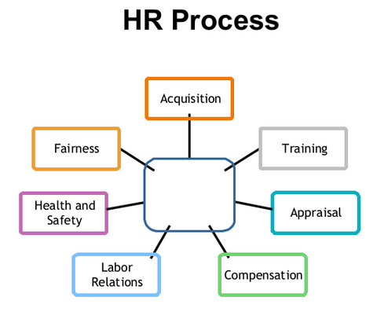

**An appraisal is a review of an employee’s work to see how well they are doing. It helps the company give feedback, recognize good performance, and suggest areas for improvement. Appraisals are also used to decide things like promotions, raises, or training opportunities. It’s a way to track progress and make sure employees grow in their roles.**

**Acquisition means finding and hiring the right people for the company. It includes recruiting, interviewing, and selecting employees to fill job roles. The goal is to ensure the company has the talent it needs to succeed.**

**Compensation refers to the pay and benefits employees receive for their work. This includes salaries, bonuses, health insurance, and other rewards. HR ensures compensation is fair, competitive, and aligns with company policies.**

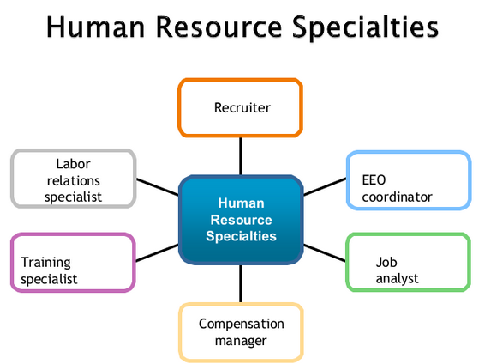**EEO** stands for **Equal Employment Opportunity**. An EEO coordinator ensures that everyone is treated fairly at work, regardless of race, gender, or other differences. They also handle discrimination issues and promote fair hiring and workplace practices.

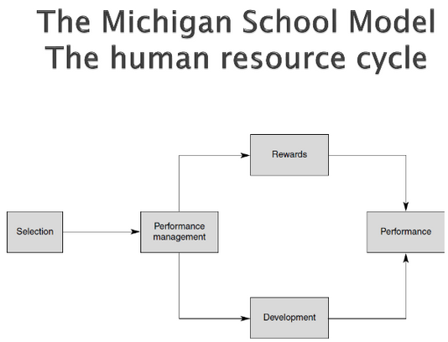

The Michigan School Model of Human Resource Management outlines the **human resource cycle**, which includes planning for staffing needs, recruiting and hiring the right candidates, training employees, and managing their performance. It also involves providing fair compensation and supporting career development while focusing on retaining talented employees. This cycle emphasizes the importance of effectively managing people to achieve business success.

Recruitment is when a company looks for people to apply for jobs. Sometimes, this job is given to outside agencies, who help find candidates.

However, the selection process, where the company chooses the best person for the job, is still controlled by the employer. They make the final decision on who to hire.

### **Recruitment and Selection Techniques**

**One-to-One Interviews**: This method helps check if a candidate is suitable for a job, such as a software developer position. However, it can be hard to show that everyone is treated equally. Sometimes, candidates who are good at talking may get hired even if they aren’t the best fit.

**Panel Interviews**: In these interviews, multiple people, such as team leads and HR, assess the candidate together. This approach helps prevent **Nepotism**, where jobs may be unfairly given to friends or family. For example, a tech company might avoid hiring the children of employees to ensure fairness, but the panel must evaluate candidates carefully to avoid poor decisions.

**Assessment of References**: Companies often ask for references to learn about candidates' past experiences. For instance, a tech firm may contact previous employers to verify a candidate's programming skills. However, legal risks have made this practice less common.

**Psychometric Tests**: Psychometric tests are assessments that measure a person’s mental abilities, personality traits, and behavior. They’re often used by companies to find the best candidates for a job.

* **Ability Tests**: Assess skills like solving coding problems.
* **Aptitude Tests**: Check if candidates can quickly learn new programming languages.
* **Personality Tests**: Evaluate how well candidates work in teams, which is important in tech roles.

**Situational Assessment:** This means looking at your job search to see how things are going. It includes checking your skills, strengths, and weaknesses, and understanding the job market and opportunities. It helps you figure out what you need to improve, what jobs are right for you, and how to present yourself well to employers.

**Task Assessment:** This involves understanding what a job needs, creating job descriptions, reviewing resumes, interviewing candidates, and making job offers. It makes sure the hiring process works well and finds the right person for the job.

**Selection Tools:** These tools must give reliable results and measure what they are meant to. For example, a coding test should show if a candidate can actually code well in real situations.

### **Nepotism and Cronyism**

* **Cronyism** is when friends or associates are given jobs or benefits based on their relationship rather than their skills or qualifications. This often occurs in politics or business, leading to unfair advantages for friends.
* **Nepotism** is when family members are given jobs or special treatment. This means hiring or promoting relatives, regardless of their qualifications, which can create a lack of fairness in the workplace.

In summary, cronyism favors friends, while nepotism favors family.

### **Selection Tools: Reliability and Validity**

* **Reliability**: This means the tool gives consistent results every time it is used. For example, if the same person takes the same test multiple times, their scores should be similar each time.
* **Validity**: Validity checks if a tool truly measures what it's supposed to. For example, if a math test is used to assess students’ problem-solving skills, it should include questions that reflect real math challenges they’ll face, not just simple calculations.

### **Ethical Duty**

Managers must create fair and legal hiring tools to make sure all candidates are treated equally. They should check interview questions and tests regularly to keep them fair and up-to-date with industry standards.